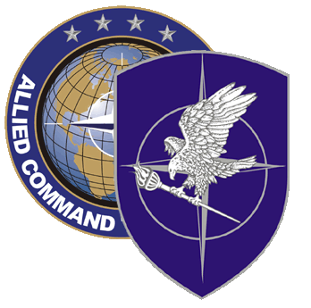
NATO SCHOOL: Global Leader in Multinational Military Education and Individual Training

S5-118 IRAQ KEY LEADER TRAINING COURSE

The aim of this course is to provide Senior Iraqi personnel with an evaluation of regional and global security environment, to strengthen the foundation for leadership, decision making, integrity, good governance and management within the defense and security sectors, to provide foundation knowledge on terrorism, to provide foundation knowledge on International Humanitarian Law, to provide the foundation of Security Sector Reform, to provide foundation knowledge on countering insurgency, and to provide students with in depth knowledge in order to improve their ability to perform public affairs activities.

Course Length: 2 weeks

Offerings per year: As requested

Class Size: ` 18 Max / 12 Min

Security Clearance: NATO UNCLASSIFIED

Rank Limitation: OF-5 and above and civilian equivalents

Prerequisites:

- Nominated by NTM-I

- Language proficiency: Not required, instantaneous interpretation is provided

Course Objectives:

At course completion, the student should be able to:

- Explain current and future security issues that will have regional and global effects,

- Understand the subject of corruption, and discuss personal conduct and conduct of officials and how this can be reinforced through ethical guidance,

- Describe the root causes of terrorism, and role of intelligence in countering terrorism,

- Describe the basics of Rule of Law issues,

- Understand the basics of Security Sector Reform, and importance of developing a security infrastructure,

- Describe the ways of countering insurgency situations,

- Conduct public affairs activities at the strategic level.

